Lab 10: CUDA Threads

Name: Waris Damkham ID: 6388014 Sec: 1

Save your file to “lab10_63xxxxxx.pdf” and upload it to MyCourses website.

**Q1.** Output from “vecAdd4.cu”. Also, pick n and T

n = 1024

T = 240

Output:

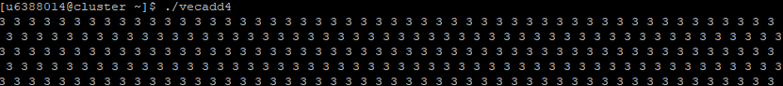

**Q2.** Source code for filling the array and its output.

Source code:

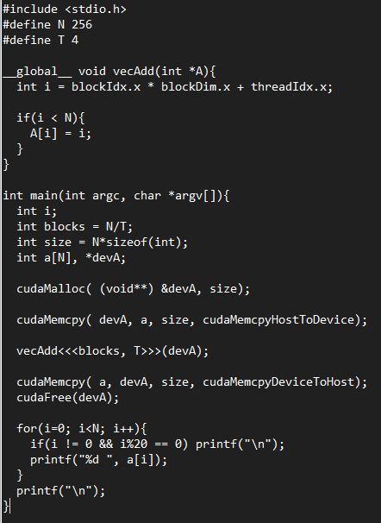

Output:

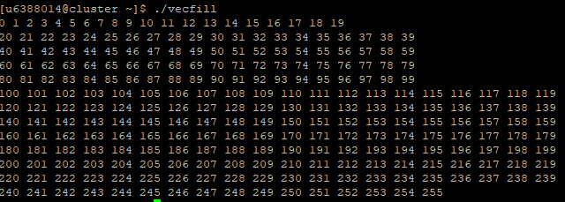

**Q3.** Output from “matmul2.cu”

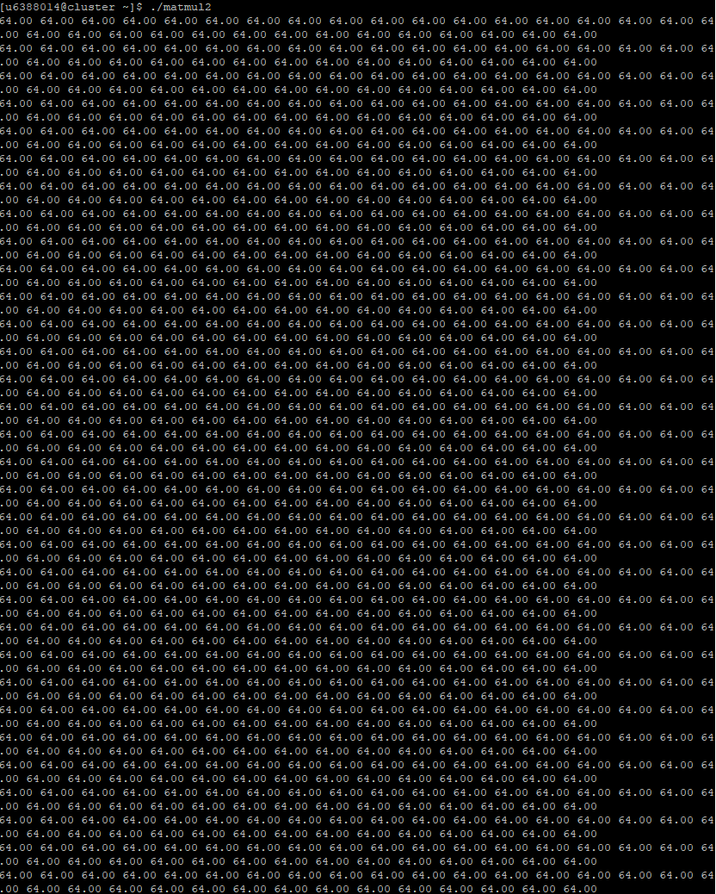

**Q4.** Source code and output from “matmul3.cu”

Source code:

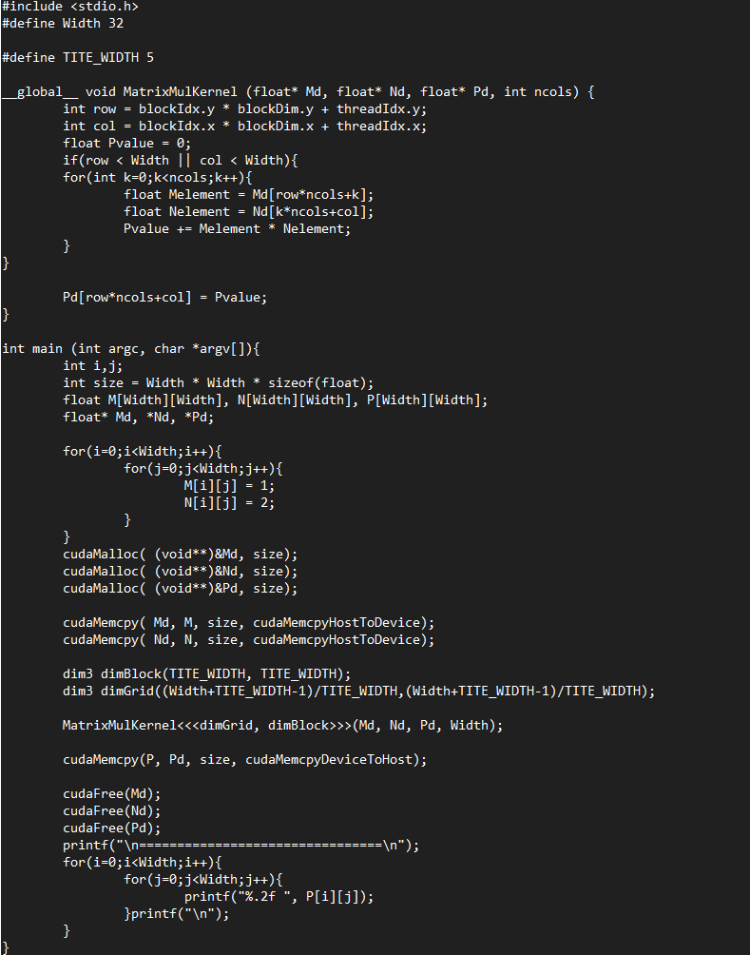

Output: 